Date:
NAME:

Multiple Choice Booklet Number:



ATAR CHEMISTRY UNITS 1 & 2 - TEST 4 (2017) TIME: 50 Minutes

Organic Chemistry

PUT A CROSS (X) THROUGH THE CORRECT ANSWER. DO NOT CIRCLE YOUR CHOICE!

1. | a | b | c | d |  | 8. | a | b | c | d
2. | a | b | c | d |  | 9. | a | b | c | d
3. | a | b | c | d |  | 10. | a | b | c | d
4. | a | b | c | d |  | 11. | a | b | c | d
5. | a | b | c | d |  | 12. | a | b | c | d
6. | a | b | c | d |  | 13. | a | b | c | d
7. | a | b | c | d |  | 14. | a | b | c | d
 |  |  |  |  |  | 15. | a | b | c | d

SECTION 1
/15
SECTION 2
/35
TOTAL
/50
PERCENTAGE

SECTION 2 – SHORT ANSWER

ANSWER ALL QUESTIONS IN THE SPACE PROVIDED

- Crude oil is a mixture of hydrocarbons. These are separated into useful products, such as fuels, using a process called fractional distillation. Petrol is a mixture that includes alkanes of chain length C₅ to C₁₀. It burns explosively in a car engine to provide energy. (4 Marks)

  - Write an equation for the complete combustion of heptane. [2 marks]

  - Heptane is known as a saturated hydrocarbon. What does this mean? [1 mark]

  - Benzene is an aromatic hydrocarbon. Benzene is an unusual chemical because it does not react as expected. How does benzene react differently to other unsaturated hydrocarbons
[1 mark]

- Write balanced equations for the following if there is a reaction. If there is no reaction, write “no reaction”. Draw all organic compounds in the equations as expanded structural formulae. (4 marks)

- Bromine gas is mixed with propane and the mixture is exposed to ultra violet light for several hours.

- Chlorine is mixed with but-1-ene and the mixture is placed in a dark cupboard

- Draw expanded structural formulae for the following compounds. (8 marks)

a. cis-pent-2-ene | b. 2-methylhex-2-ene
c. methylcyclobutane | d. 3-ethylhept-1-ene
e. 2,3-dimethylpent-2-ene | f. 1-ethyl-2,3-dimethylbenzene
g. 1,1-dibromo-2,2-difluoroethene | h. trans-2,5-dimethylhex-3-ene

- Name the following compounds using the IUPAC system of nomenclature: (8 marks)
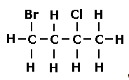
a. b.
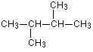

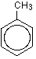
c. d.
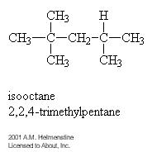

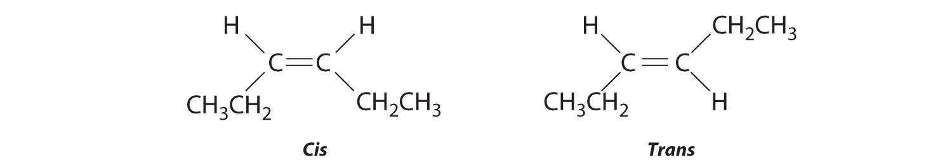
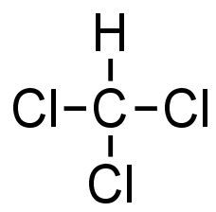
e. f.

g. h.
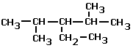
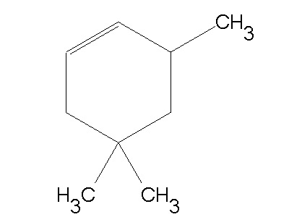

_________________________ ___________________________

- A straight chain hydrocarbon has a molar mass of 86 gmol⁻¹ (6 Marks)

  - What homologous series does this hydrocarbon belong to? [1 mark]

  - Draw and name (IUPAC) two isomers of this hydrocarbon. [4 marks]

  - What type of isomers are these? [1 mark]

- A student combusts a sample of propane gas in limited oxygen to produce a black solid and water only. (5 marks)

  - Write a balanced equation for the reaction that occurred. [1 mark]

  - What mass of black solid would be formed if 6.05 g of propane was burnt? [4 marks]

-End of Test-

